ECE 445

Senior Design Laboratory

Project Proposal

CHARM

CHeap Accessible Resilient Mesh for Remote Locations and Disaster Relief

**Team No. 1**

Martin Michalski

(martinm6@illinois.edu) MELISSA PAI

(mepai2@illinois.edu) TREVOR WONG

(txwong2@illinois.edu)

***TA***: Kai Chieh (Jeff) Chang

***Professor***: Victor Gruev September 15, 2022

**Abstract**

This document is a more detailed look at our project when compared to our RFA. We pro- vide high-level implementation details, requirements, and safety considerations.

**Contents**

1. Introduction 1
   1. Problem 1
   2. Solution 1
   3. Visual Aid 1
   4. High-Level Requirements 2
2. Design 3
   1. Block Diagram 3
   2. Subsystem Overview 3
      1. Power Management Subsystem 3
      2. Sensor Subsystem 3
      3. Routing Subsystem 4
      4. System Monitor 4
   3. Subsystem Requirements 4
      1. Power Management Subsystem 4
      2. Sensor Subsystem 4
      3. Routing Subsystem 4
      4. System Monitor 5
   4. Tolerance Analysis 5
3. Ethics & Safety 7

References 9

# Introduction

We provide details as to the problem we aim to address, along with our proposed solu- tion, in context.

## Problem

Hurricanes, earthquakes, tsunamis, and other natural disasters all have the capability to destroy cellular- and inter- networks, cutting off victims from emergency services, unaf- fected survivors from worried loved ones, and rescuers from their command and control. This was the case in NYC after Hurricane Sandy, with a large area of the city facing cellu- lar outages for a month after the hurricane [1], and in Japan which experienced blackouts and cellular outages after a 2011 tsunami [2].

Remote areas also suffer from limited connectivity, with connections to cabling, cell tow- ers, and other networking hardware being few and far between [3]. In the case of an emergency, such communicative sparsity may even be fatal, e.g. a farmer which has a heart attack and is not able to call for emergency services or relatives to come to their aid.

## Solution

To solve these problems, we would like to create a set of meshing, cheap, lightweight, and self-contained wireless access points, deployable via drone. After being placed by drone or administrator, these access points form a WiFi network, usable by rescuers, survivors, and civilians. Our network will have QoS features to prioritize network traffic originating from rescuers. Having nodes/access points deployable by drone ensures we are able to establish timely connectivity in areas where search and rescue operations are still unable to reach.

Over the course of the semester, we will produce a couple of prototypes of these network nodes, with built in power management and location sensing. We aim to demonstrate our limited network’s mesh capabilities by setting up a mock network on one of the campus quads, and connecting at various locations.

## Visual Aid

We provide an in-context view of CHARM in Figure 1. The cloud-hosted System Monitor keeps tabs on the status of each CHARM node, with the nodes themselves being inter- connected, and serving their connected clients.

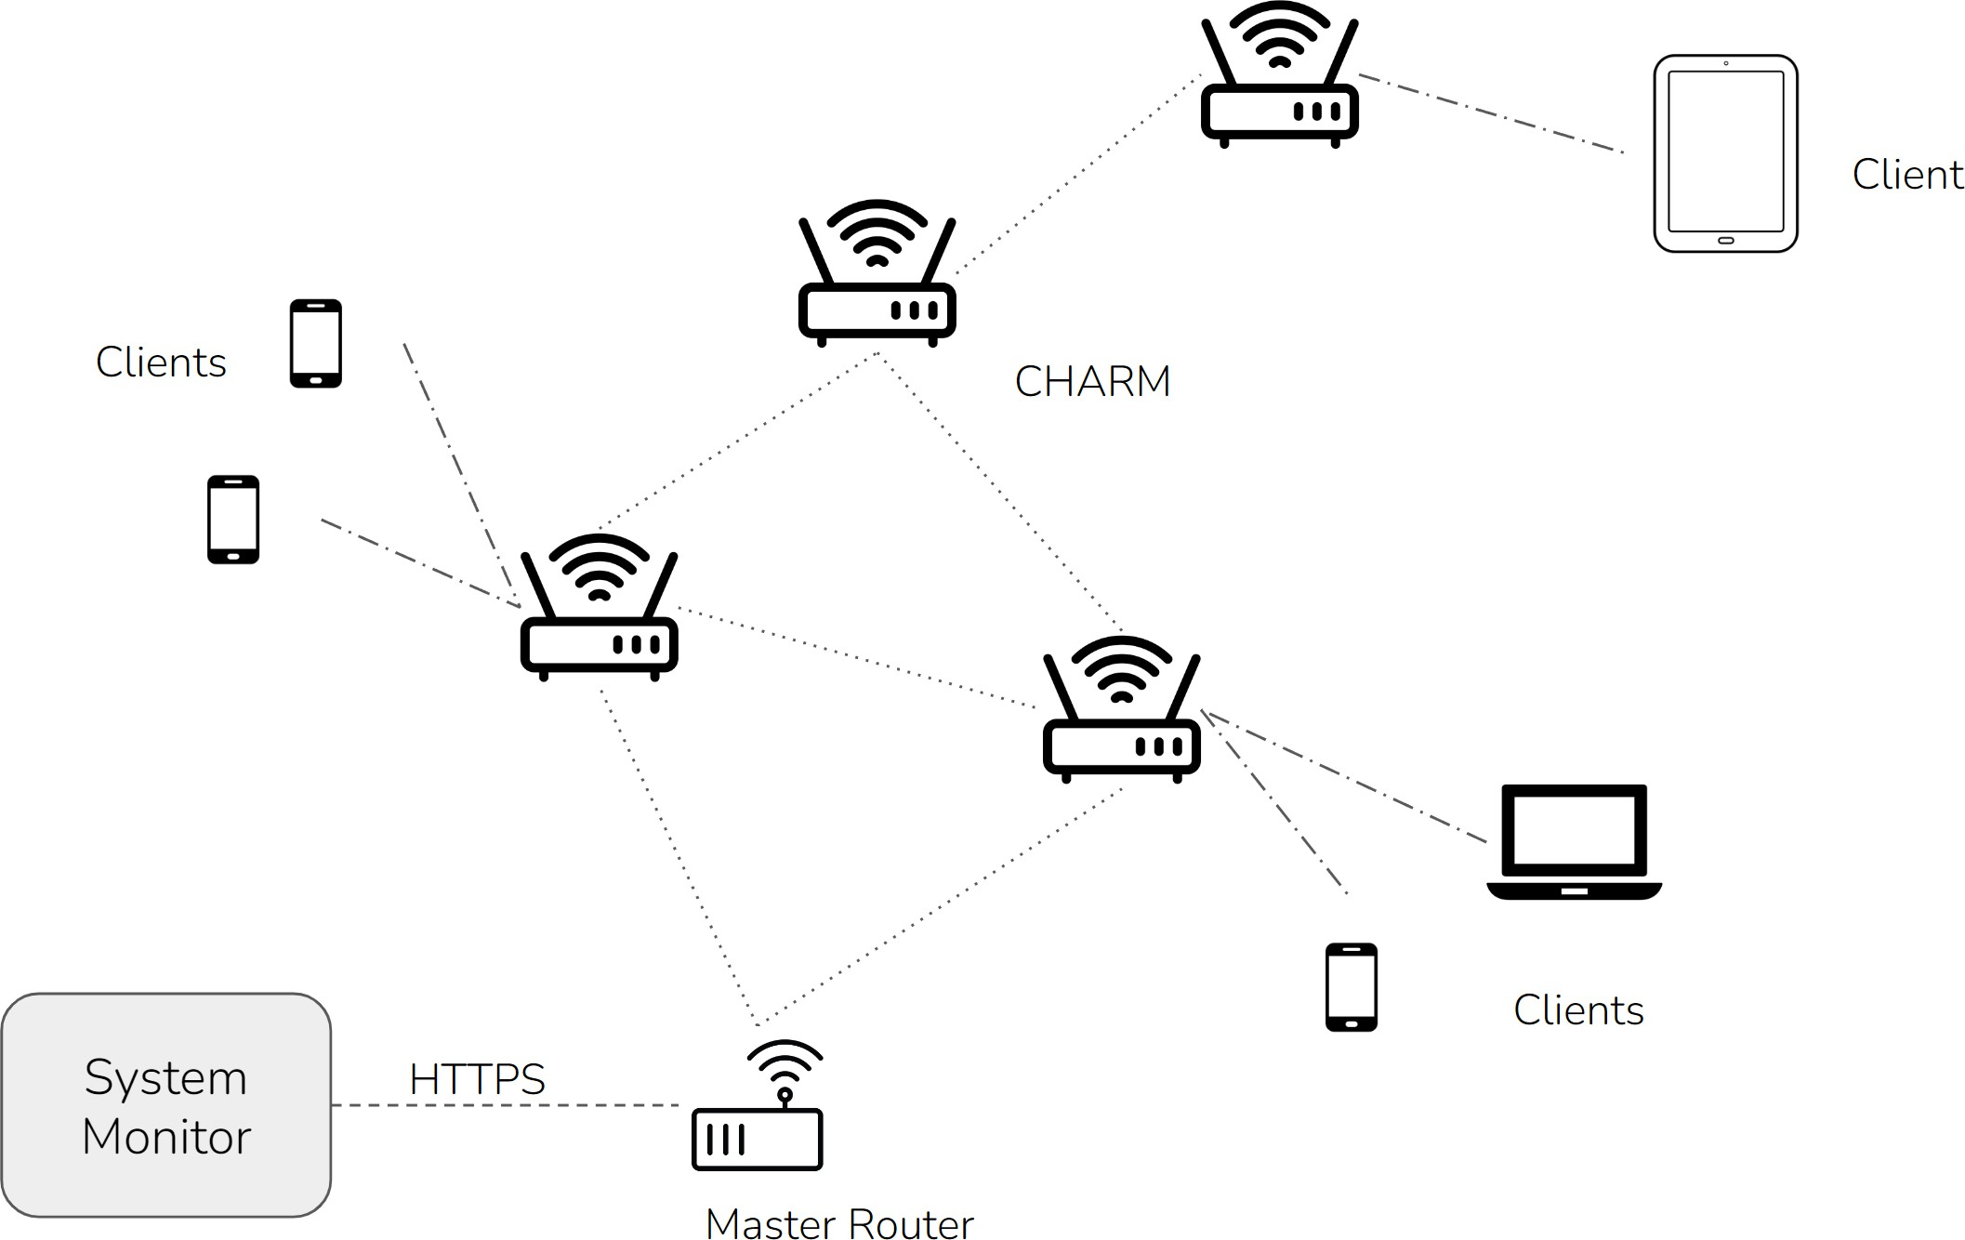

Figure 1: High-Level Overview of the CHARM System

## High-Level Requirements

To be considered successful, we aim to hit the following goals.

1. The system shall cover at least 7500 m2 with publicly-accessible WiFi, using a maxi- mum of 5 CHARM nodes.
2. Each node shall weigh no more than 1*.*5 kg and not exceed 8000 cm3 of volume.
3. The system shall be monitored via a web-interface which is able to enumerate the lo- cation (*±*10 m), battery voltage(*±* 0*.*1V), and networking information for each node.

# Design

## Block Diagram

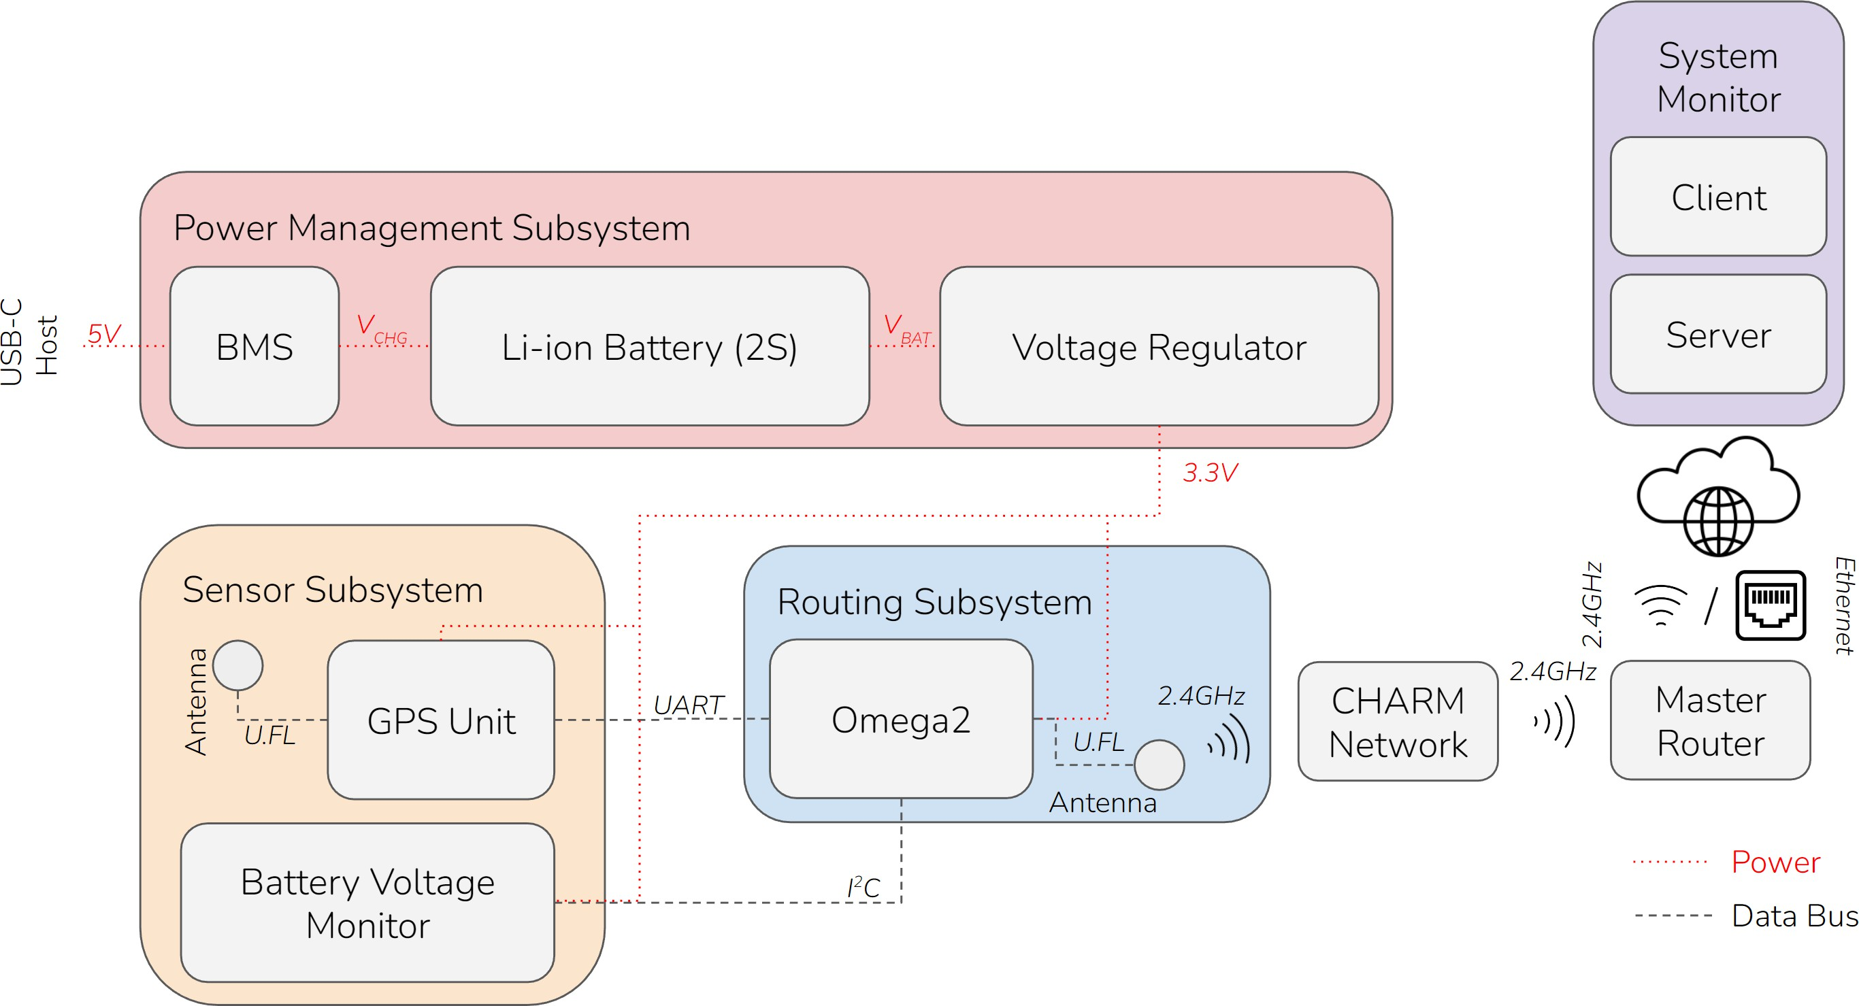

Figure 2: Block Diagram

## Subsystem Overview

Our design is divided into four subsystems, which are implemented in both hardware and software.

### Power Management Subsystem

The power management subsystem handles charging, discharging, and voltage regula- tion. Specifically, it includes a USB-C port that allows the nodes to be charged with a standard USB-C charger. A boost converter and constant-current constant-voltage charg- ing IC increase the voltage and deliver it safely to the batteries. Finally, the output of the batteries is fed through an on/off switch and into a buck converter, which reduces the voltage to power the microcontroller and sensors.

### Sensor Subsystem

The sensor subsystem contains the hardware necessary for each node to measure its po- sition and battery voltage. Nodes will contain a GPS IC, a GPS antenna, and a voltage di- vider feeding into an ADC that will relay battery voltage data to the microcontroller.

### Routing Subsystem

The routing system contains the Omega2S+ microcontroller itself and a WiFi antenna for mesh networking. Most of the submodule is implemented in software, which includes a meshing algorithm and regularly sending metrics to the system monitor.

### System Monitor

The system monitor is a full-stack web application that displays the location and status of every node. The backend is written in Node.js and includes methods to save and retrieve node data. The frontend is written using React.js and the Google Maps API to visualize the location and status of each node.

## Subsystem Requirements

The requirements for each of our subsystems.

### Power Management Subsystem

* + - 1. The system must provide overcurrent, overvoltage, undervoltage, and short-circuit protection.
      2. It must charge 2S Li-ion battery cells with a standard USB-C charger and a peak charging current of at least 400mA.
      3. It must provide a stable 3.3 *±* 0.1 V power source that supports up to 2A of current draw.

### Sensor Subsystem

* + - 1. The system must provide battery voltage measurements (*±* 0.1 V).
      2. It must provide a location within 10 meters of the true location when the device is deployed in an area free of large buildings or other obstacles.

### Routing Subsystem

* + - 1. Each node must automatically find and connect with nearby nodes to create a mesh network.
      2. Each node must provide a publicly accessible WiFi network with a bandwidth of at least 1 Mbps.
      3. Assuming a connection to the internet can be established, it must be able to send telemetry containing location and battery voltage data at least once per minute.

### System Monitor

* + - 1. The monitor must be able to display all node locations on a map.
      2. It must show all information on mobile and desktop screens and work with both touchscreen and mouse/keyboard.
      3. It must refresh the data at least once per minute.

## Tolerance Analysis

One of the most important aspects of our design is the battery charging circuit. As sug- gested by a blog post [4], we utilized the MCP73844 IC to control battery charging. Our schematic closely resembles the reference schematic from the datasheet [5], and can be see in Figure 3.

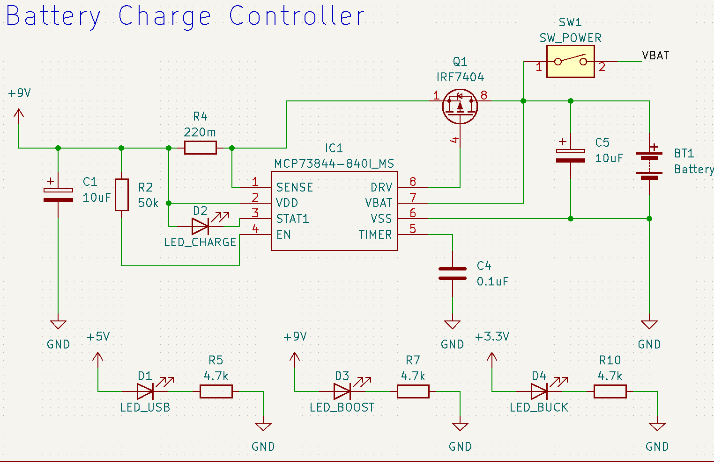

Figure 3: Schematic View of our Battery Charging Circuit

Arguably the most important passive component is the shunt resistor (R4), as this deter- mines the charge current. The datasheet[5] specifically recommends the ERJ-6RQFR22V 220 mΩ, 1%, 1/8W shunt resistor for *∼* 500mA of charging current. The formula for the resistor value is given in Equation 1.

*R*sense = *V*fcs

*I*reg

(1)

In Equation 1 *V*fcs is the Fast Charge Current Regulation Threshold, which ranges from 0.1V to 0.12V with a nominal value of 0.11V [5]. *I*reg is the desired charging current, in amps.

We want 500mA charging, therefore *R*sense = 0*.*11 = 0*.*22 or 220mΩ. Given the resistor has a 1% tolerance, we can also calculate the minimum and maximum charge current. See equations 2 and 3.

0*.*5

min *I*reg =

0*.*1

0*.*2222

= 0*.*45 = 450mA (2)

max *I*reg =

0*.*12

0*.*2178

= 0*.*551 = 551mA (3)

These are all acceptable currents for our application and meet our design goal of sup- plying at least 400mA of peak charging current to our battery cells. Our batteries have 3400mAh of capacity, so a safe 1C charging speed would be anything up to 3.4 Amps of current. It is important to limit the current to not overload the USB power source and allow for lower capacity batteries to be safely used, so it makes sense to charge at less than 3.4 Amps.

The power dissipated over the resistor is given by *P* = *RI*2. Given a worst case current of 551mA, the resistor dissipates up to 66.8mW of heat, which is within spec of our se- lected resistor. This calculation matches that made in the datasheet, so their shunt resistor recommendation is acceptable for our use case.

# Ethics & Safety

In terms of ethics, our group mainly followed IEEE Code of Ethics adopted by the IEEE Board of Directors through June 2020 [6]. We recognize that technologies have the ability to affect one’s life thus we hold ourselves to the highest ethical standard when working professionally in a team including but not limited to:

1. **Seeking and providing truthful reviews and feedback of our technical work** [6]

Within our group, we established a multi-stage review/revision process for both software and hardware designs. We will follow course guidelines for timely feed- back and confirmation with Teaching Assistant and Professors. On top of existing resources, we also reached out to personal contacts in industry and from extracur- ricular experiences for design reviews.

Recently, Professor Lumetta has reached out to us and introduced us to Jack Blevins who is a UIUC ECE Alumni with 50+ years of project experience across all indus- tries. Jack Blevins expressed interest in our ideas and offered to share his advice and insights. We were able to collect unique insights and feedback on our concept during our meeting with Jack.

1. **Constantly learning and acquiring new skills throughout the training and design**

**process** [6]

All members have completed the CAD training and will be finishing all the proper training required by the course. We will also ensure to consult expertise (Professors, Teaching Assistants, Machine Shop Technicians) if questions or uncertainties arise during this project. This group consists of members with different areas of expertise, including firmware, web development, AI, and robotics. By working together, we will be able to constantly learn from one another.

1. **Treating all people with respect and kindness and ensuring these codes are prop-**

**erly followed** [6]

To ensure good teamwork and efficient communication, our team established a Dis- cord server with dedicated channels for subsystems, logistics, and meetings. With a shared Google Drive storage space, we made sure that all documentation is ac- cessible for all team members. GitHub is used for software and schematic version control along with storage. This system not only keeps track of all technical details but also confirms that all members are on the same page.

Regarding the safety and related regulations in this project:

1. For each mesh node device, the electrical components will be enclosed in a water re- sistance plastic box to minimize the odds of potential injury. Our team had talked to the ECE machine shop director and acquired information on how we can maximize water resistance in our design.
2. For network connectivity and sensor data, we will ensure that the user’s network connection is private and secure when connecting to our system. Data in IP packets

(including those containing node telemetry) shall not be used for any purpose other than general system health monitoring.

1. We will ensure that our project follows any relevant license terms and API terms of service for all software and part models used in CHARM.

# References

1. J. DeYoung. “When disaster strikes: Decentralized tech a safety mesh from black- outs.” (2020), [Online]. Available: [https://cointelegraph.com/news/when-disaster-](https://cointelegraph.com/news/when-disaster-strikes-decentralized-tech-a-safety-mesh-from-blackouts) [strikes-decentralized-tech-a-safety-mesh-from-blackouts](https://cointelegraph.com/news/when-disaster-strikes-decentralized-tech-a-safety-mesh-from-blackouts) (visited on 07/11/2020).
2. M. Hamblen. “’Massive damage’ from Japan quake hits communications.” (2011), [Online]. Available: [https://www.computerworld.com/article/2506865/-massive-](https://www.computerworld.com/article/2506865/-massive-damage--from-japan-quake-hits-communications.html) [damage--from-japan-quake-hits-communications.html](https://www.computerworld.com/article/2506865/-massive-damage--from-japan-quake-hits-communications.html) (visited on 07/11/2020).
3. U. Ashraf, A. Khwaja, J. Qadir, S. Avallone, and C. Yuen, “Wimesh: Leveraging mesh networking for disaster communication in poor regions of the world,” *CoRR*, vol. abs/2101.00573, 2021. arXiv: [2101.00573.](https://arxiv.org/abs/2101.00573) [Online]. Available: [https://arxiv.org/](https://arxiv.org/abs/2101.00573) [abs/2101.00573.](https://arxiv.org/abs/2101.00573)
4. S. Bhowmick. “Designing an Advanced 2S Li-Ion/ Li-Po Battery Charge System us- ing MCP73844 IC.” (2021), [Online]. Available: [https://circuitdigest.com/electronic-](https://circuitdigest.com/electronic-circuits/designing-an-advance-2s-li-ion-li-po-battery-charger-system-using-mcp73844-ic) [circuits/designing- an- advance- 2s- li - ion- li - po- battery- charger- system- using-](https://circuitdigest.com/electronic-circuits/designing-an-advance-2s-li-ion-li-po-battery-charger-system-using-mcp73844-ic) [mcp73844-ic](https://circuitdigest.com/electronic-circuits/designing-an-advance-2s-li-ion-li-po-battery-charger-system-using-mcp73844-ic) (visited on 07/11/2020).
5. *”Advanced Single or Dual Cell Lithium-Ion/ Lithium-Polymer Charge Management Con-* *trollers”*, MCP73841/2/3/4, Microchip, Nov. 2012.
6. IEEE. “”IEEE Code of Ethics”.” (2016), [Online]. Available: [https://www.ieee.org/](https://www.ieee.org/about/corporate/governance/p7-8.html) [about/corporate/governance/p7-8.html](https://www.ieee.org/about/corporate/governance/p7-8.html) (visited on 02/08/2020).